LAB PROGRAMMS (R Programming)
CSA5802-DEVSECOPS

1.Adding Two Numbers: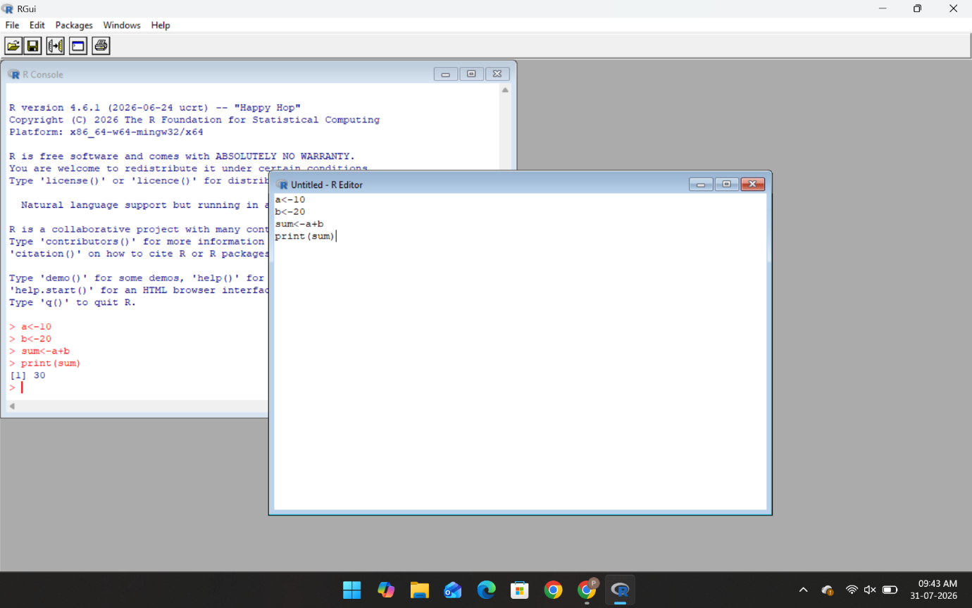
2.Find the Biggest of given Two Numbers:
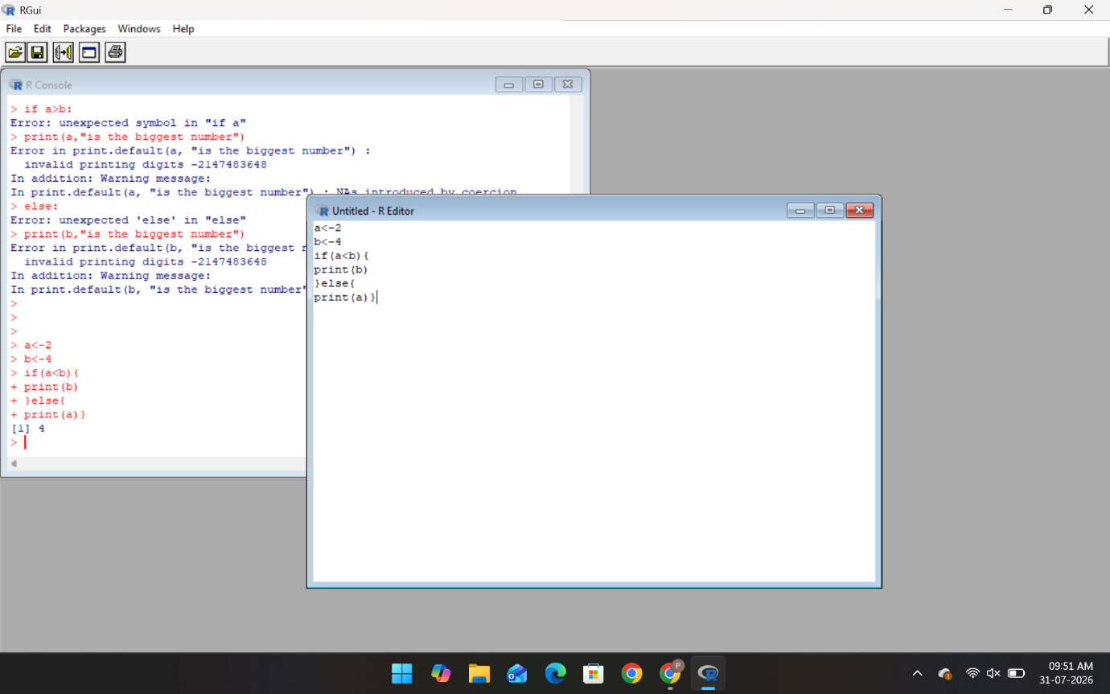

3.To find whether the given number is even or odd:
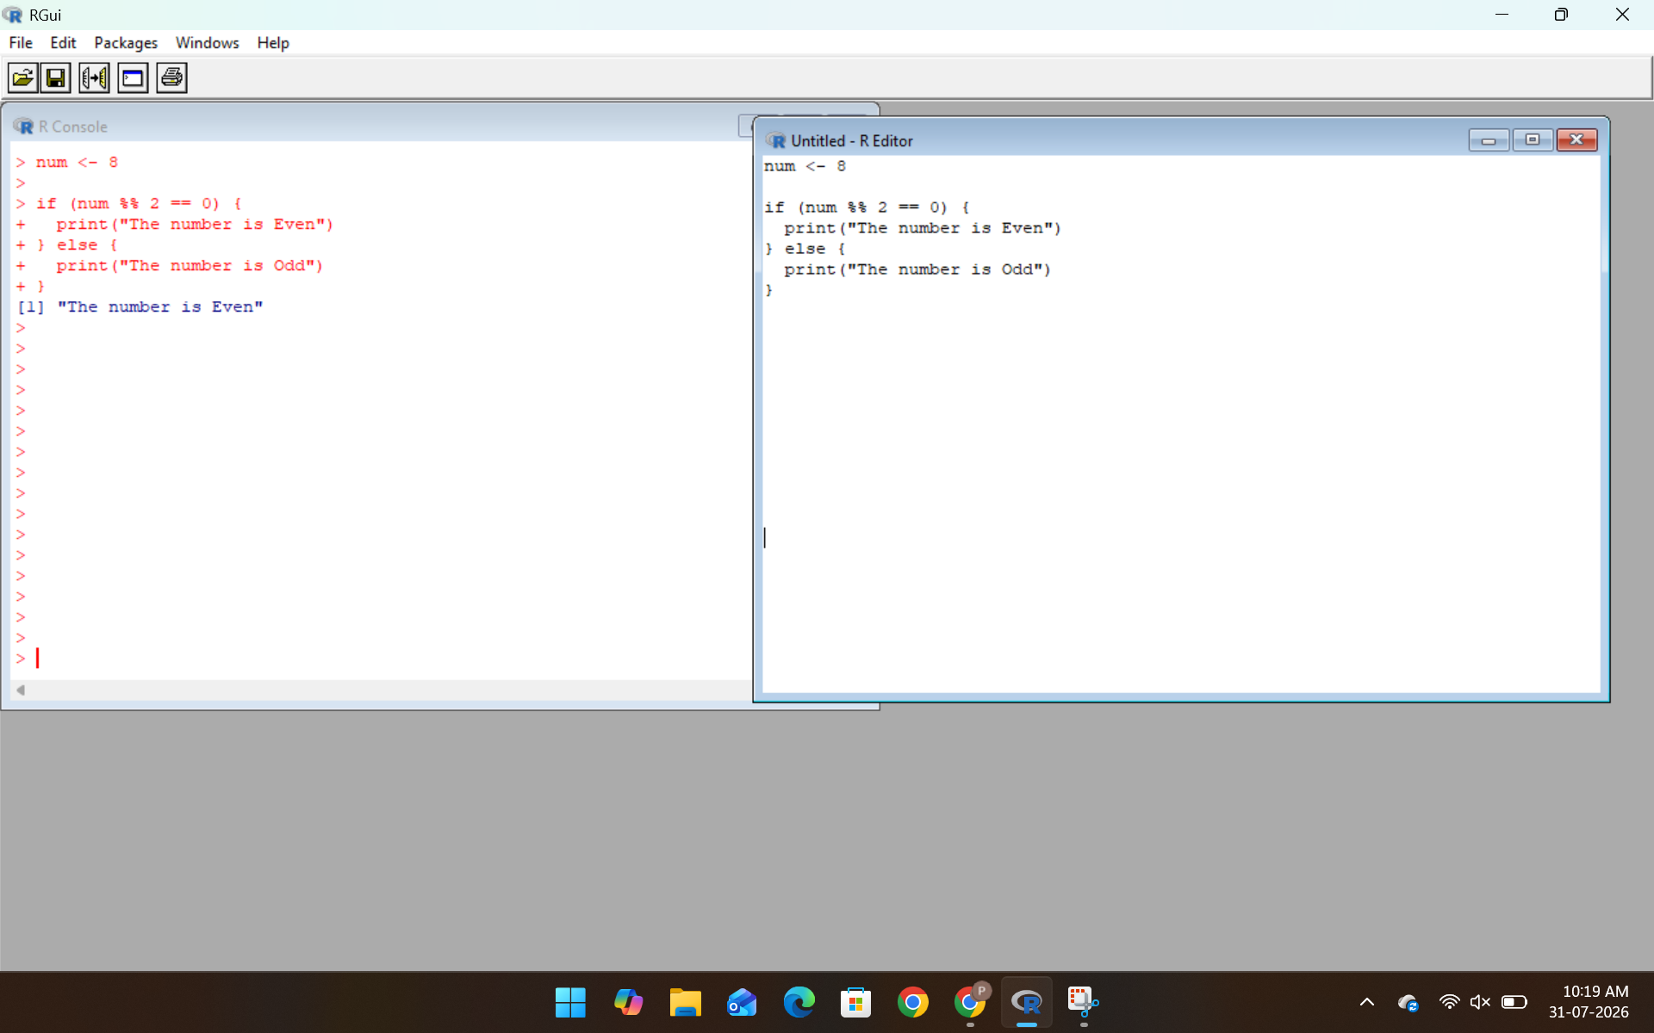
4.Calculate the sum of two numbers using user input:
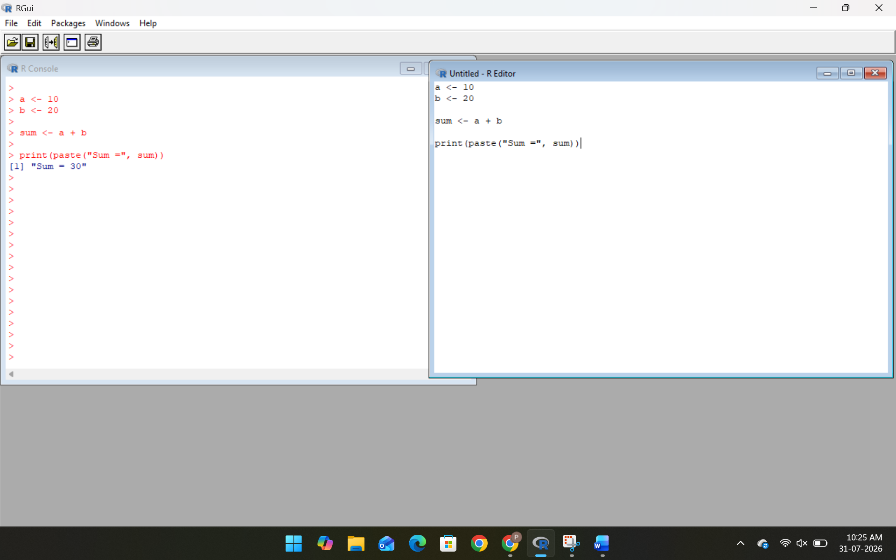
5.To swap two numbers:
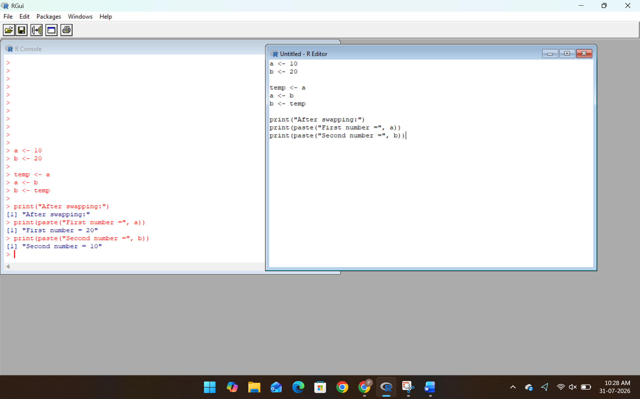
6.To Generate Fibonacci series:
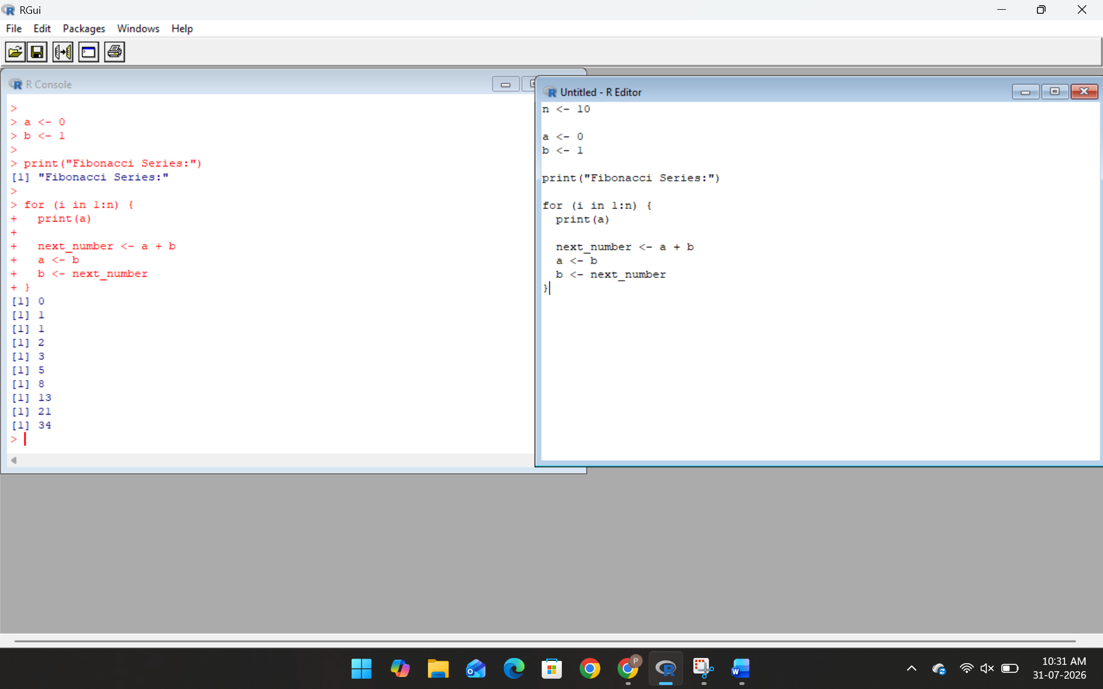

7.To perform the matrix addition:
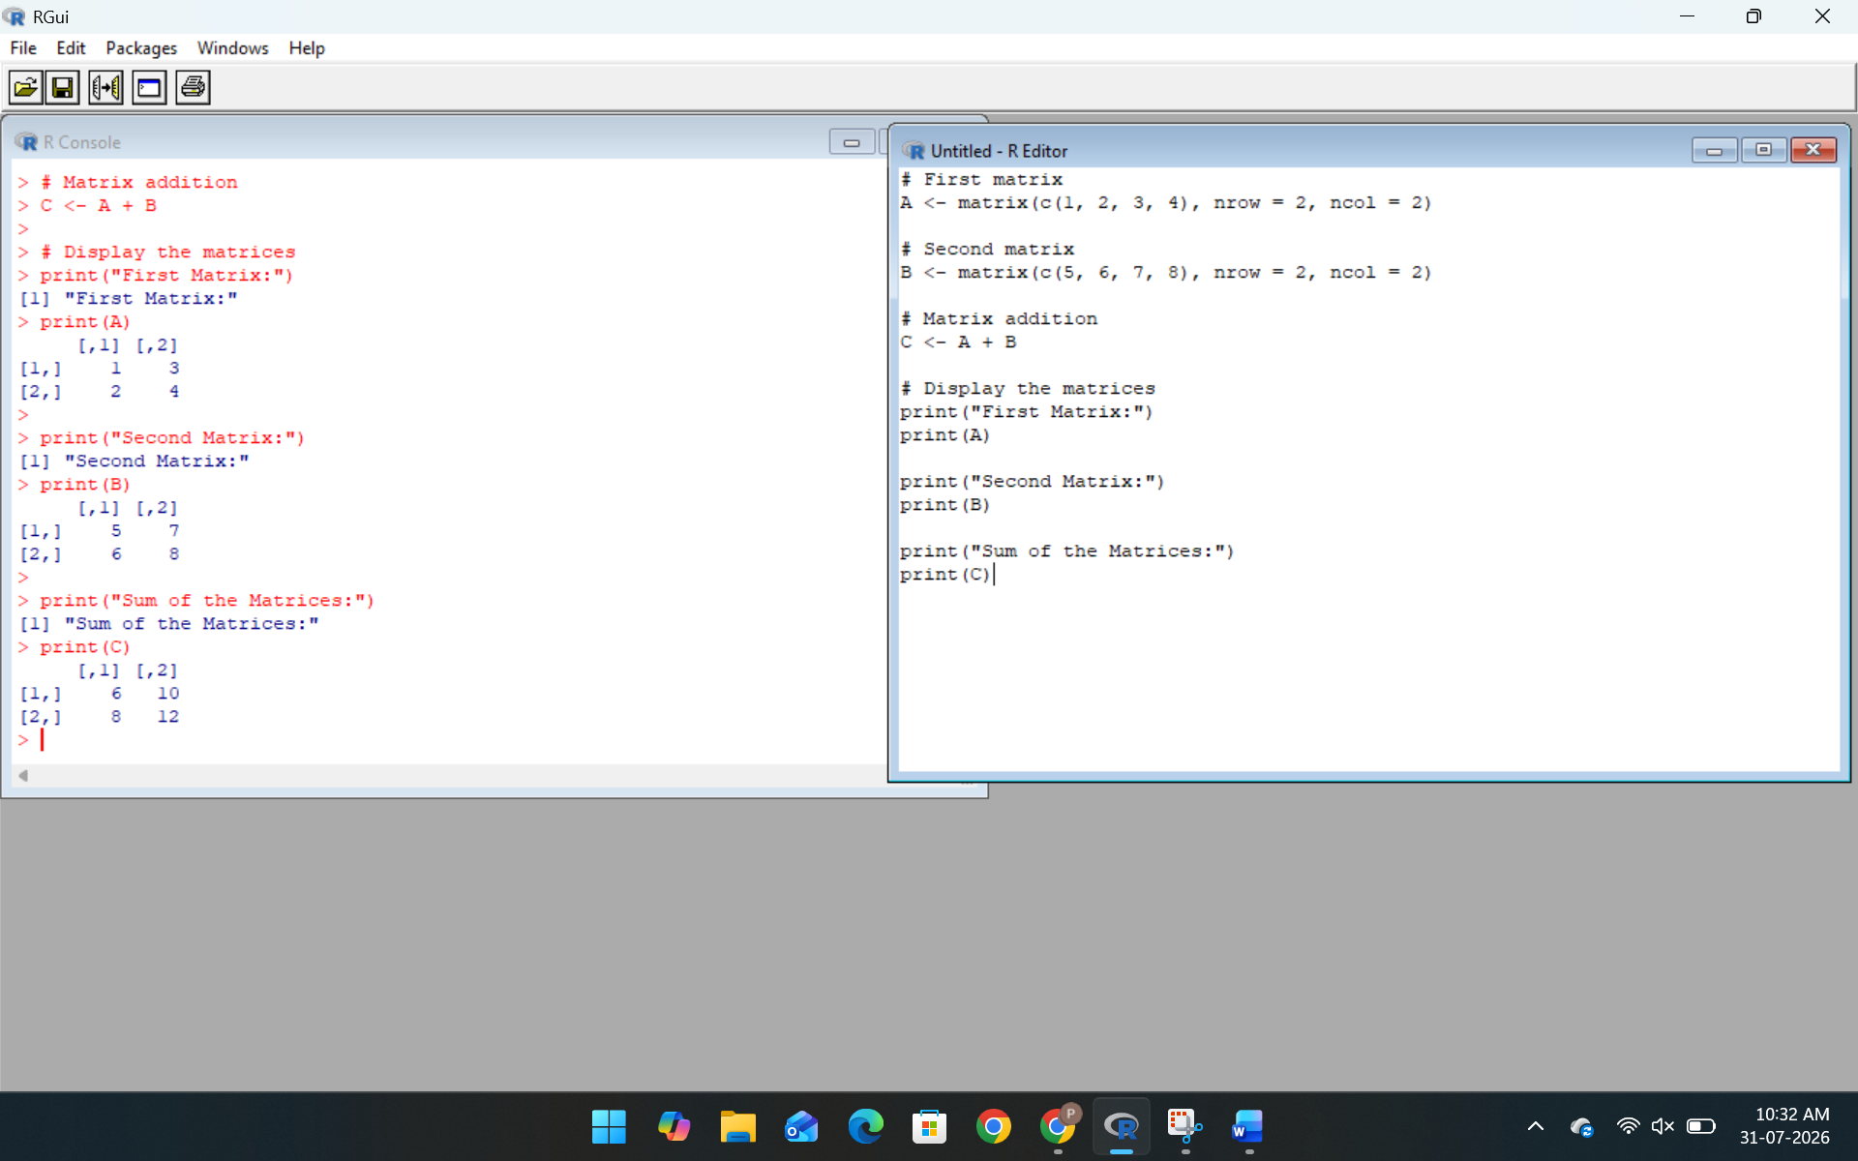
8.To perform the matrix multiplication:
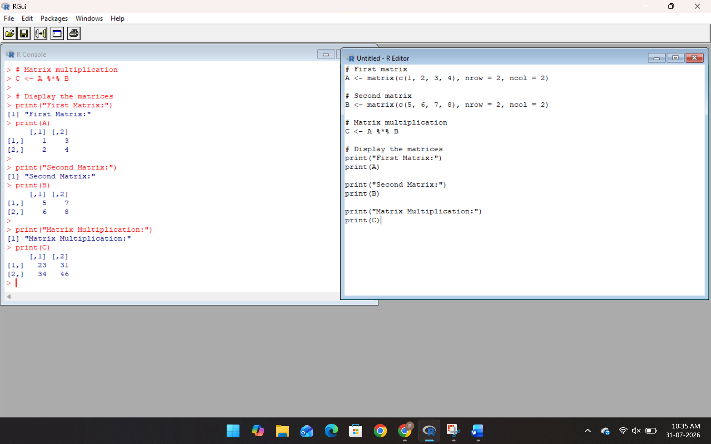

9.To find the maximum and minimum in the vector:
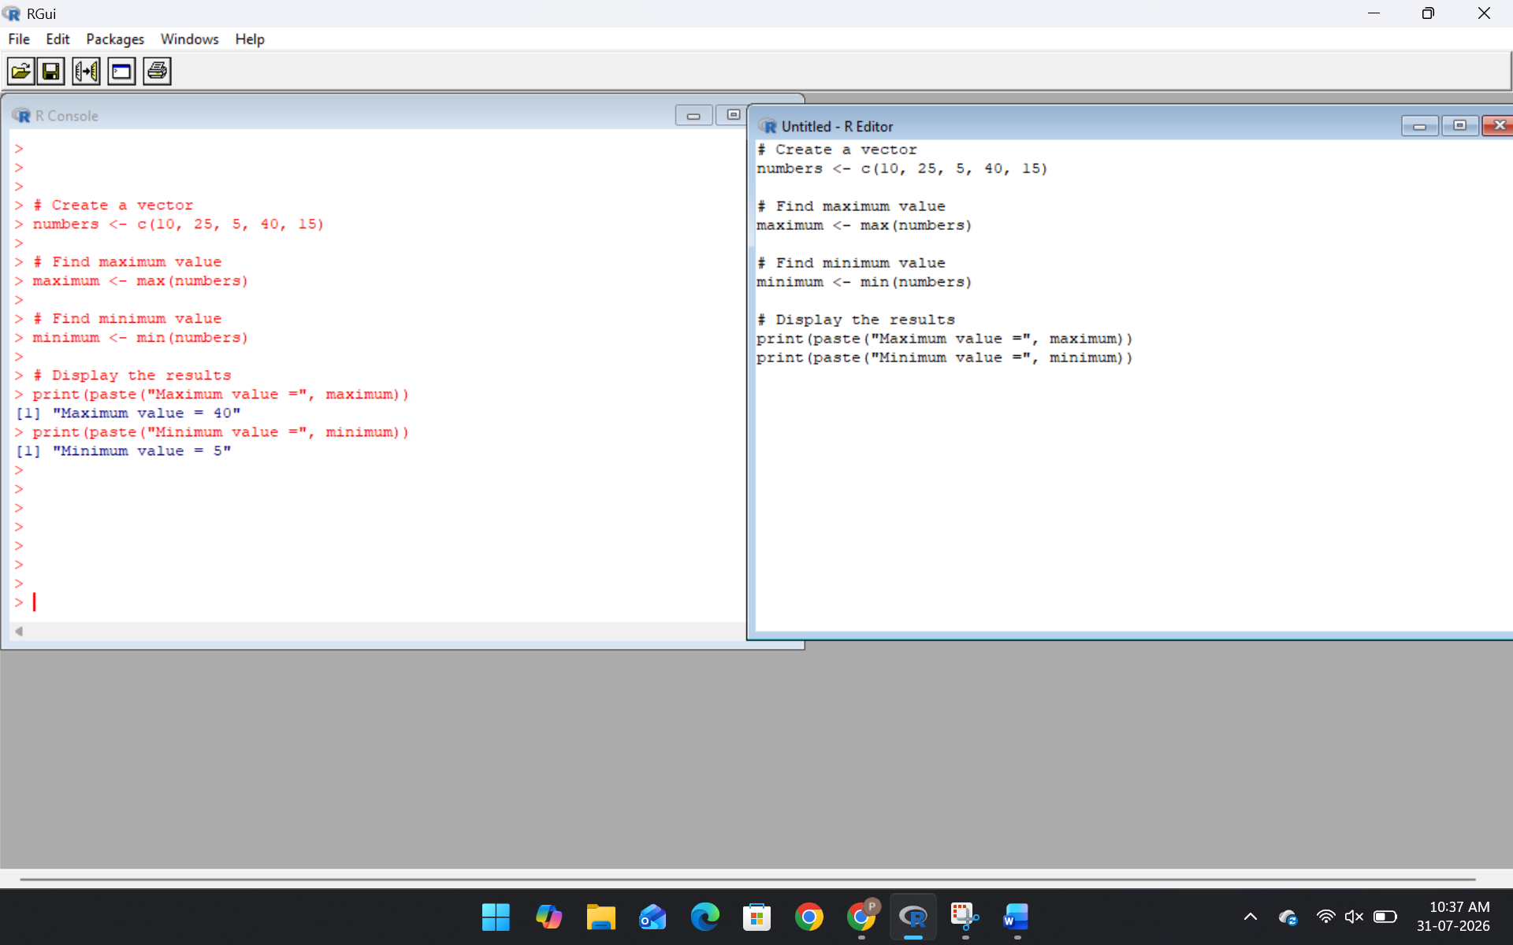
10.To create a data frame and display student marks:
